# System Architecture

## Hardware components selection

1. **Microprocessor** that will be responsible for processing data from the sensors: ESP32.
2. **Accelerometer** whose function is to measure speed and **Gyroscope** whose function is to measure the direction (one single module with both): MPU-9250
3. **GPS module** that will be responsible for providing the geographic location: NEO-6M
4. **Buttons** to interact with the display: Rotary Encoder Module
5. **Display** whose function is to display the measurements: 296x128, 2.9inch E-Ink display module
6. **Memory** whose function is to store direction, velocity and geographical location logs: Flash Memory from ESP32.
7. **Power source:** lithium-ion rechargeable batteries.

## Data Transfers

The MCU will process data coming from sensors:

* UART from GPS module.
* SPI from gyroscope w/ accelerometer.

The display will show the data measurements from the MCU by SPI.

There will be telemetry in which data will be transmitted by MQTT.

## Processing Algorithms

There will be filtering and fusion of sensors done by the MCU to get correct and trustworthy measurements: Kalman Filter and Complementary Filtering.

## User Interface

In the main mode, there will be the display of the following: //CLOCK IN MAIN MODE

In the menu mode, there will be the display of the following:

## 

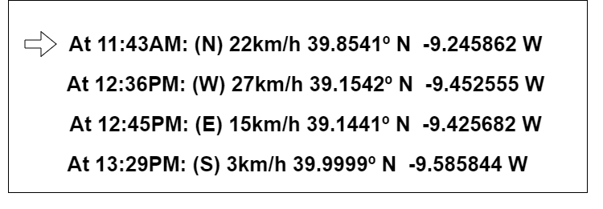In the GPS logs mode, there will be the display of the following:

## Power Management

//AFTER DISPLAY

## Software Structure

APP

DRIVERS

EXPRESSIF

## Provisional Electrical Schematics